IMC Campaign Plan for Bionade
Name
Institution
Date

IMC Campaign Plan for Bionade
Target market
The target market for IMC campaigns will be strictly from Singapore city, and it will be concerned about middle and high-income earners. Demographic marketing segmentation will be applied to identify the income levels of the target population. Among the most crucial reason for choosing this target market is because this category of persons may have an extra coin to purchase the beverage due to their moderate and high living standards. Besides, those living beyond the poverty line may not be able to buy, since they only concentrate on basic needs. Power Distance index score, as one of Hofstede's dimensions, is recorded at 74, meaning that the target population beliefs and expects power to be equally distributed. Income distribution for middle-income earners ranges between $9,023 and $9,293. Besides, that of high-income earners ranges between $10,400 and $15,000. IMC pricing will be based on the current market demands, prices of competitors, and the cost of manufacturing the product.
The positioning of the product
Positioning can be defined as the perspective of the target market towards a particular product concerning that of competitors. The positioning of Bioande will put more emphasis on the 4ps of the marketing mix; product, price, place, and promotion. Notably, the target market should have a clear view of the products in regards to its name, composition, and use (Akpoyomare, 2015). Again, the price of bioande should be in line with market demands and the costs of competitors. The advertisements should be launched within the busy street, places where one can find the target population. Akpoyomare (2015) suggested that the type of promotion on the product should be understandable and located at a strategic location to be viewed by a wide range of potential customers. The marketing of Bioande receives a challenge from rival products from other competitors, including Coca-Cola and Malaysia Dairy industries. As a result, the promotion will be tactically designed to show more advantages of buying bioande as compared to products from rival companies.
Creative one-Billboard
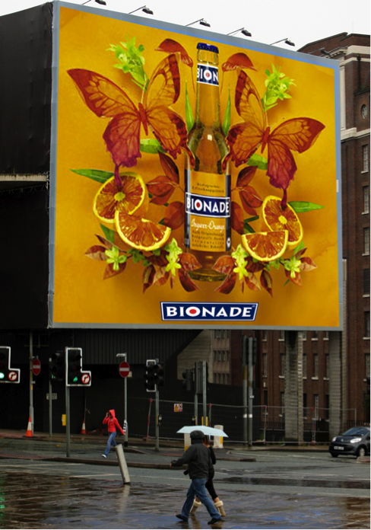
Context and justification
The first creative is an outdoor billboard with Boonade’s brand, which will be located in the busy street and roundabouts within Singapore city CBD (Vernuccio & Ceccotti, 2015). This type of advertising will contribute significantly to escalating sales of bionade since it has the potential of reaching a massive number of potential customers (Vernuccio & Ceccotti, 2015). The primary purpose of the billboard is to create awareness of the product to both existing and prospective customers. The entire advertisements will have the same design, and similar tag line “Ferment Your Thirst” will as well be featured in all the billboards.

Creative two- 3D picture
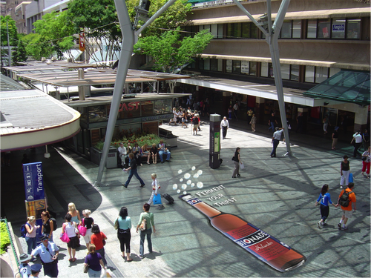
Context and justification
The above picture represents a 3D advertising of bionade drink. It is among the attractive types of advertising, which are placed on the sidewalks where potential customers can stand to have a broad view. 3D advertising makes peoples stand at paths, analyze, and digest the picture’s message swiftly (Vassileva, 2017). The image to be drawn should look precisely like the one portrayed at the fermentation stage of production. The existing and interested customers will take a photo of the picture and post it on social media platforms, including Facebook and Twitter. As a result, it will be able to reach a considerable number of persons in Singapore Akpoyomare (2015). In addition to 3D pictures, bionade men will be distributed in the streets of Singapore, whereby they will doing free artwork, graphics, and animations of the brand.
Creative three- Coater/table advertising
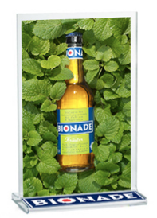
Context and justification
Table advertising is also an outdoor method for creating awareness of the product to potential customers. It entails designing table coaters for restaurants, hotels, clubs, cars, and cafes. This approach will require the company to develop strands with bionade brand that will stand firmly on the serving tables of the above-mentioned places (Akpoyomare, 2015). Coaster advertising will be emphasized more in strategic and central areas, which accommodates a massive number of potential customers. Importantly, the bionade company should ensure that these chosen places have enough supply of the drink, for customers to have easy access. Again, this approach will instigate customers to buy due to its inclusion in the restaurant's menu (Vassileva, 2017). It may happen that some customer does not know of bionade existence. As such, they will have the opportunity to familiarize themselves with the drink as a result of advertisements displays.
Appropriateness and Cohesiveness of Campaign for Selected Target Market and Positioning
The selected campaign methods are effective yet cohesive as far as the target market and positioning are concerned. The first campaign method is billboards that will be strategically positioned along the busy streets of Singapore (Akpoyomare, 2015). This method will be cohesive and appropriate for middle and high-income earners since they are the largest working population in the city, thereby standing a higher chance of making more sales. On its part, 3D advertising pictures in Singapore city is also useful for the target population, because it is in busy streets where all these persons pass by while returning home from work. A million potential customers can view the 3D picture in a single day.Scully (2015) suggested that the use of table coasters stands as among appropriate methods for advertising since they can reach a massive number of potential customers. Since the table coasters are placed in strategic places like restaurants and clubs, the target population will get to know of its existence, hence developing the urge to buy.
Organization and communication
Organization and communication are among the critical functions of an organization that are managed by the marketing department. Vassileva (2017) opines that the organization in marketing is vital because it addresses all the issues related to advertising and public relations. Notably, it is through an active organization that a healthy public relationship will be attained, hence increased sales in bionade. Communication in advertising bionade will be vital since the target population needs to have the full information of the product, including its use, purpose, and communication (Vassileva, 2017). Importantly, the customers will also require vivid information regarding Bionade advantages over other products, including coca-cola and Pepsi drinks.
Potential weakness and problems with the campaign
Lack of access to enough funds is among the potential problem and weaknesses of the campaign due to the limited budget of $ 80,000. The cost of advertising and branding has been escalating over recent years (Vernuccio & Ceccotti, 2015). As a result, the cost of putting in place a billboard, 3D, and Coater tables may be high, hence resulting in a limitation. Again, the process of assembling the three methods of campaign demands the utilization of expertise skills, and sourcing them is a challenge (Vernuccio & Ceccotti, 2015). Overall, advertising demand collective responsibility and it may be costly to acquire the appropriate art skill.

References
Akpoyomare, O. B., Adeosun, L. P. K., & Ganiyu, R. A. (2015). Approaches for generating and
evaluating product positioning strategy. International Journal of Business Administration, 4(1), 46.
Scully, P., Macken, A., Leddin, D., Cullen, W., Dunne, C., & Gorman, C. O. (2015). Food and
beverage advertising during children’s television programming. Irish Journal of Medical Science (1971-), 184(1), 207-212.
Vassileva, B. (2017). Marketing 4.0: How technologies transform marketing
organization. Óbuda university e-Bulletin, 7(1), 47.
Vernuccio, M.,& Ceccotti, F. (2015). Strategic and organisational challenges in the integrated
marketing communication paradigm shift: A holistic vision. European Management Journal, 33(6), 438-449.

